**Project Design Phase**

**Solution Architecture**

|  |  |
| --- | --- |
| Date | 8 th june2025 |
| Team ID | LTVIP2025TMID42578 |
| Project Name | ResolveNow |
| Maximum Marks | 4 Marks |

## 🔹 Solution Architecture – ResolveNow

### Purpose of the Architecture:

The solution architecture for **ResolveNow** is designed to ensure:

* Seamless **complaint submission**, **intelligent assignment**, and **real-time communication**
* Clear separation of **frontend**, **backend**, **database**, and **real-time socket layer**
* Easy **scalability**, **security**, and **deployment** in both cloud and on-premise environments

### Key Goals:

* Align the system structure with business needs: **faster resolution**, **smart routing**, and **transparency**
* Define clear **components**, **data flow**, and **integration points**
* Support multiple **user roles**: User, Agent, and Admin
* Ensure the system is **modular** and easy to maintain/scale

### 🧱 Solution Architecture Layers:

1. **Frontend (React.js)**
   * User dashboard
   * Complaint submission form
   * Chat interface
   * Agent/admin dashboards
2. **Backend (Node.js + Express)**
   * API endpoints (e.g., /submit-complaint, /get-agent, /chat)
   * Business logic: complaint assignment, status tracking, role permissions
3. **Database (MongoDB)**
   * Collections for users, complaints, messages, assignments, and logs
4. **Real-Time Communication (Socket.io)**
   * Enables bi-directional communication for chat between agents and users
5. **Authentication (JWT)**
   * Ensures secure login sessions for all user roles
6. **Admin Tools**
   * Manual reassignment
   * Analytics dashboard
   * Complaint status audit and control
7. **Deployment**
   * Deployed on cloud (e.g., Render/Heroku for backend, Vercel/Netlify for frontend)
   * Scalable to cloud platforms like AWS, Azure, or GCP

**Example - Solution Architecture Diagram:**

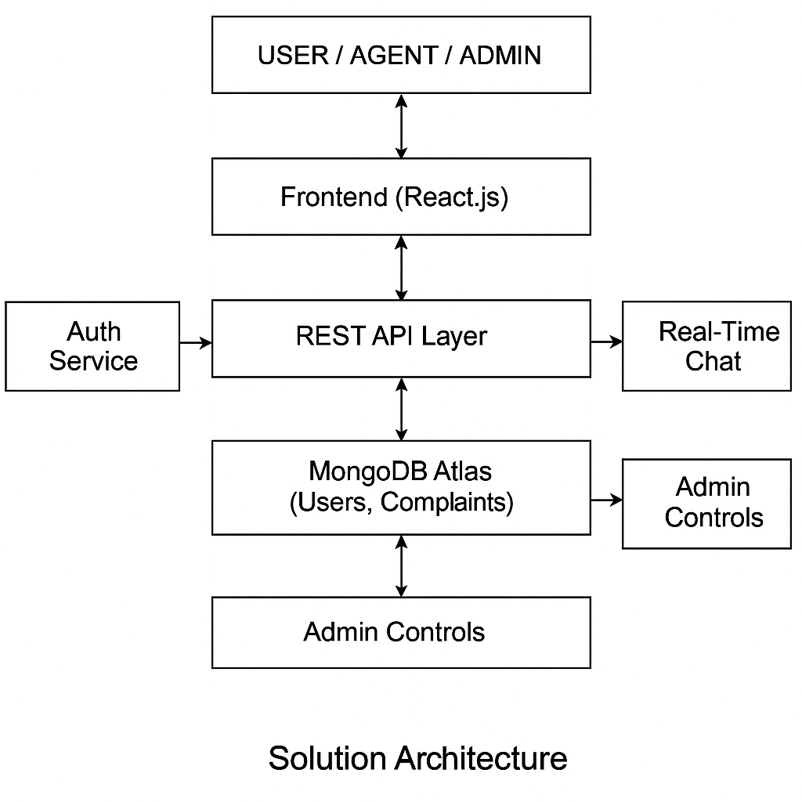

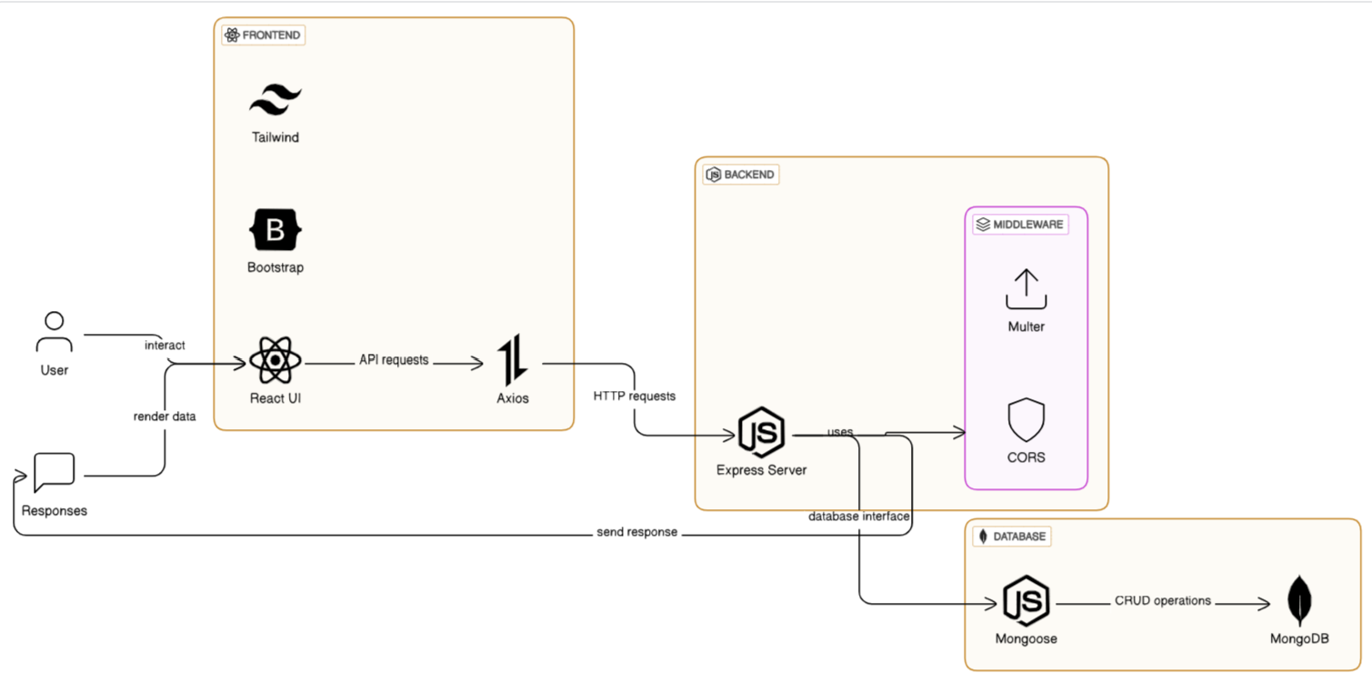

*Figure 1: Architecture and data flow of the voice patient diary sample application*

**Reference:** [**https://aws.amazon.com/blogs/industries/voice-applications-in-clinical-research-powered-by-ai-on-aws-part-1-architecture-and-design-considerations/**](https://aws.amazon.com/blogs/industries/voice-applications-in-clinical-research-powered-by-ai-on-aws-part-1-architecture-and-design-considerations/)